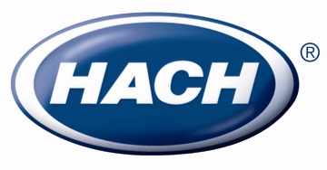
FOR IMMEDIATE RELEASE

Contact: Kristyn Keefe
970-663-1377 ext. 2494
kkeefe@hach.com

Hach WIMSTM, Version 7.3 Now Available

Loveland, Colo. – (May 1, 2012) – A new version of Hach (www.Hach.com) WIMSTM, Version 7.3, was released on May 1st, 2012. Hach WIMSTM is a software platform specifically designed for water and wastewater utilities, providing easy access and visibility to data from many disparate sources for reporting, analysis and monitoring.

Hach WIMSTM, Version 7.3 introduces many new features including support for using WIMS online on the Apple iPad mobile device, support of the MS SQL Server 2012 Express 10GB database, 20 new or enhanced regulatory templates for water and wastewater compliance reporting, enhanced printer and data entry functions and easy report generation with six new built-in one-click reports:

- Basic Data Statistics report
- Full Statistics report
- Daily report
- Influent Flow report
- Variables With No Data report
- User Activity Report

New customers will automatically receive the latest released version. Existing customers on support are able to download the update from the customer support portal. Hach WIMSTM, Version 7.3 is available now by contacting iimsupport@hach.com or 1-800-677-0067.

About Hach Company
For more than 60 years, Hach Company has developed innovative solutions used to test the quality of water, liquids and air. Manufactured and distributed worldwide, Hach systems are designed to simplify analysis by offering sophisticated on-line instrumentation, accurate portabllaboratory equipment, high-quality prepared reagents, complete easy-to-follow methods, and life-time technical support.

###

